We, Abdul Rehman and Imran Qureshi, declare that the attached assignment is our own work inaccordance with the Seneca Academic Policy.No part of this assignment has been copied manually or electronically from any other source (including web sites) or distributed to other students.

# DBS301 Assignment 1

Group # 5

Group Members:

Abdul Rehman Seneca ID: 149019176

Imran Qureshi Seneca ID:023966005

|  |  |  |
| --- | --- | --- |
|  | Name | Task(s) |
| 1 | Imran Qureshi | Q6-14, Q26-30 |
| 2 | Abdul Rehman | Q1-5, Q15-25 |

1. **Write the SQL command to change the movie year for movie number 1245 to 2008.**

update movie

set movie_year = 2008

where movie_num = 1245;



1. **Write the SQL command to change the price code for all Action movies to price code 3.**

update movie

set price_code = 3

where movie_genre ='ACTION';

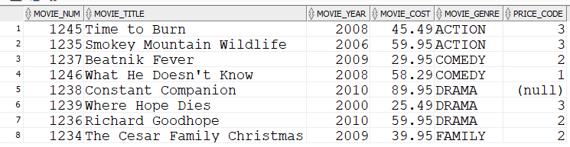

1. **Write a single SQL command to increase all price rental fee values by $0.50.**

update price

set price_rentfee = price_rentfee + 0.5;

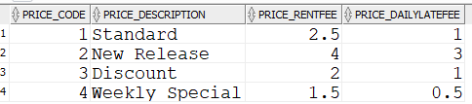

1. **Write a query to display the movie title, movie year, and movie genre for all movies.**

select movie_title,movie_year,movie_genre

from movie;

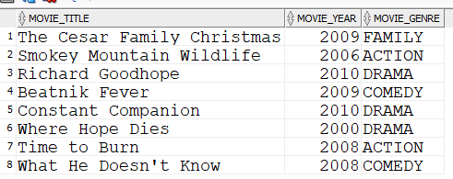

1. **Write a query to display the movie year, movie title, and movie cost sorted by movie year in descending order.**

select movie_year,movie_title,movie_cost

from movie

order by 1 desc;

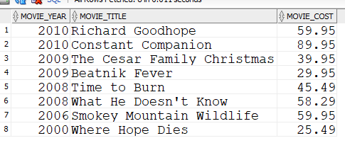

**6. Write a query to display the movie title, movie year, and movie genre for all movies sorted by movie genre in ascending order, then sorted by movie year in descending order within genre**

Ans:6

Select MOVIE_TITLE "Movie Title", MOVIE_YEAR "Movie Year", MOVIE_GENRE "Movie Genre"

From MOVIE

Order By MOVIE_GENRE, MOVIE_YEAR DESC;

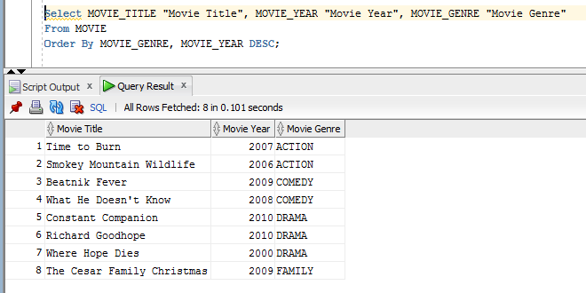

**7. Write a query to display the movie number, movie title, and price code for all movies with a title that starts with the letter “R” (result shown in Figure P7.75).**

Select MOVIE_NUM "Movie Number", MOVIE_TITLE "Movie Title", PRICE_CODE "Price Code"

From MOVIE

Where MOVIE_TITLE LIKE 'R%';

1. **Write a query to display the movie title, movie year, and movie cost for all movies that contain the word “hope” anywhere in the title. Sort the results in ascending order by title (result shown in figure P7.76).** 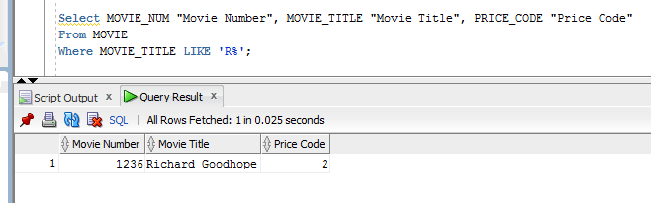

Select MOVIE_TITLE "Movie Title”, MOVIE_YEAR "Movie Year", MOVIE_COST "Movie Cost"

From Movie

Where MOVIE_TITLE LIKE '%hope%'

Order By MOVIE_TITLE;

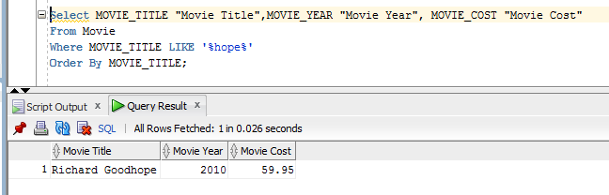

**9.Write a query to display the movie title, movie year, and movie genre for all action movies (result shown in Figure P7.77).**

Select Movie_Title "Movie Title",MOVIE_YEAR "Movie Year",MOVIE_GENRE "Movie Genre"

From Movie

Where MOVIE_GENRE = 'ACTION';

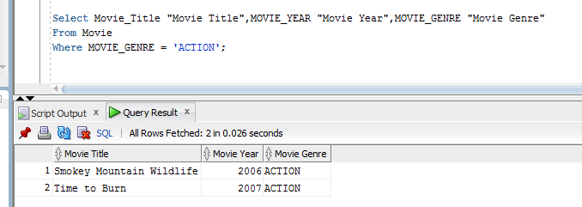

**10.Write a query to display the movie number, movie title, and movie cost for all movies with a cost greater than $40 (result shown in Figure P7.78).**

Select Movie_Num "Movie Number", MOVIE_TITLE "Movie Title",MOVIE_COST "Movie Cost"

from movie

where movie_cost > 40;

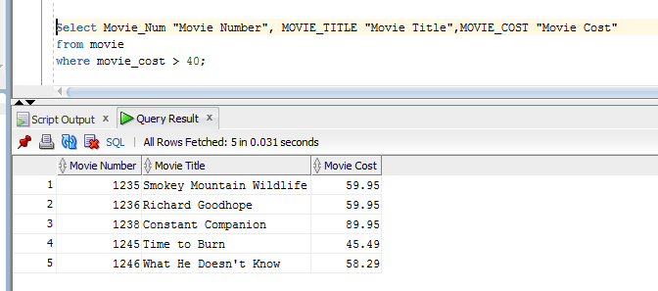

**11.Write a query to display the movie number, movie title, movie cost, and movie genre for all movies that are either action or comedy movies and that have a cost that is less than $50. Sort the results in ascending order by genre.**

Select Movie_Num "Movie Number", Movie_Title "Movie Title",MOVIE_Cost "Movie Cost",MOVIE_GENRE "Movie Genre"

From Movie

Where MOVIE_GENRE IN ('ACTION','COMEDY') and movie_cost < 50

order by Movie_Genre;

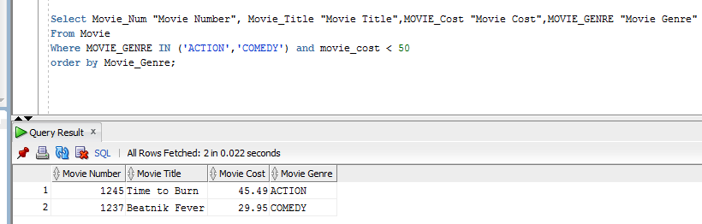

**12.Write a query to display the movie number, and movie description for all movies where the movie description is a combination of the movie title, movie year and movie genre with the movie year enclosed in parentheses (result shown in Figure P7.80).**

Select Movie_Num "Movie Number", Movie_Title ||' '||'('||Movie_Year||')'||' '|| Movie_Genre "Movie Description"

From Movie;

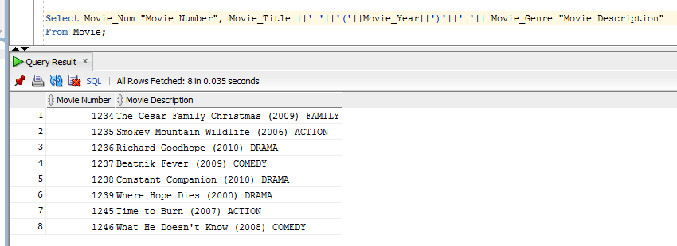

**13.Write a query to display the movie genre and the number of movies in each genre (result shown in Figure P7.81).**

Select Movie_Genre "Movie Genre", Count(*) "Number of Movies"

from Movie

Group by Movie_Genre

Order by Movie_Genre;

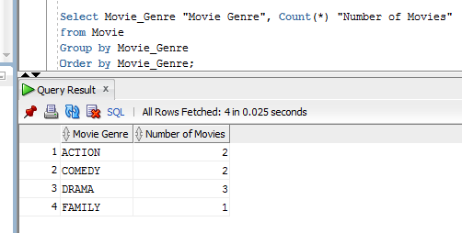

**14.Write a query to display the average cost of all of the movies (result shown in Figure P7.82).**

Select Avg(Movie_Cost) "Average movie cost"

from movie;

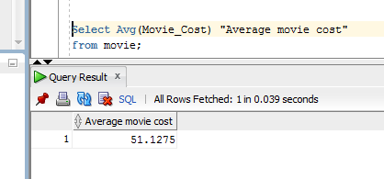

**15.Write a query to display the movie genre and average cost of movies in each genre (result shown in Figure P7.83).**

select movie_genre, trunc(avg(movie_cost),2) "Average Cost"

from movie

group by movie_genre

order by movie_genre;

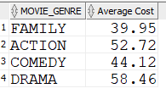

**16.Write a query to display the movie title, movie genre, price description, and price rental fee for all movies with a price code**

select m.movie_title, m.movie_genre, p.price_description, p.price_rentfee

from movie m, price p

where m.price_code = p.price_code

order by movie_genre;

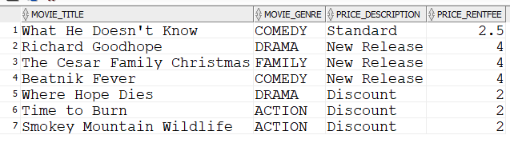

**17.Write a query to display the movie genre and average price rental fee for movies in each genre that have a price**

select movie_genre, avg(price_rentfee) "Average Rental Fee"

from movie m, price p

where m.price_code = p.price_code

group by movie_genre;

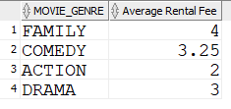

**18. Write a query to display the movie title, movie year, and the movie cost divided by the price rental fee for each movie that has a price to determine the number of rentals it will take to break even on the purchase of the movie (result shown in Figure P7.86).**

select movie_title,movie_year, round(movie_cost/price_rentfee,2) "Breakeven Rentals"

from movie m, price p

where m.price_code = p.price_code

order by movie_year;

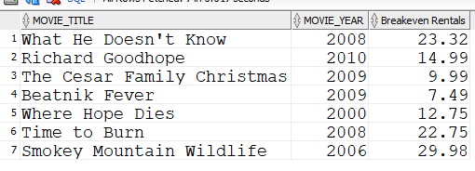

**19. Write a query to display the movie title and movie year for all movies that have a price code.**

select movie_title, movie_year

from movie

where price_code is NOT NULL

order by movie_year;

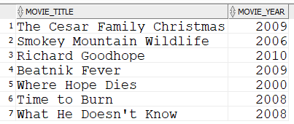

**20. Write a query to display the movie title, movie year, and movie cost for all movies that have a cost between $44.99 and $49.99.**

select movie_title, movie_year, movie_cost

from movie

where movie_cost BETWEEN 44.99 AND 49.99;



**21. Write a query to display the movie title, movie year, price description, and price rental fee for all movies that are in the genres Family, Comedy, or Drama (result shown in Figure P7.89).**

select movie_title, movie_year, price_description, p.price_rentfee, movie_genre

from movie JOIN price p

using(price_code)

where movie_genre IN ('FAMILY','COMEDY','DRAMA')

order by movie_genre;

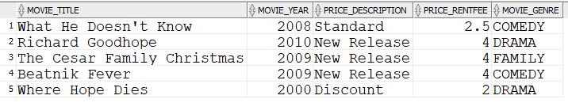

**22. Write a query to display the movie number, movie title, and movie year for all movies that do not have a video.**

select movie_num, m.movie_title, m.movie_year

from movie m LEFT JOIN video v

using (movie_num)

where vid_num IS NULL;



**23. Write a query to display the membership number, first name, last name, and balance of the memberships that have a rental.**

select distinct mem_num, m.mem_fname, m.mem_lname, m.mem_balance

from membership m left JOIN rental r

using(mem_num)

where r.rent_num is NOT NULL

order by 1;

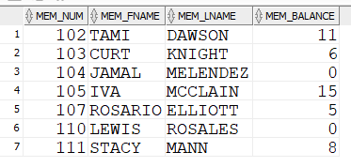

**24. Write a query to display the minimum balance, maximum balance, and average balance for memberships that have a rental.**

select min(mem_balance) "Minimum Balance" , max(mem_balance) "Maximum Balance", round(avg(mem_balance),2) "Average Balance"

from membership m join rental r

using(mem_num)

where rent_num is NOT NULL;



**25. Write a query to display the membership name (concatenate the first name and last name with a space between them into a single column), membership address (concatenate the street, city, state, and zip codes into a single column with spaces (result shown in Figure P7.93).**

select trim(mem_fname) ||' ' || trim(mem_lname) "Membership Name", trim(mem_street) || ' ' || trim(mem_city) || ' ' || trim(mem_zip) "Membership Address"

from membership;

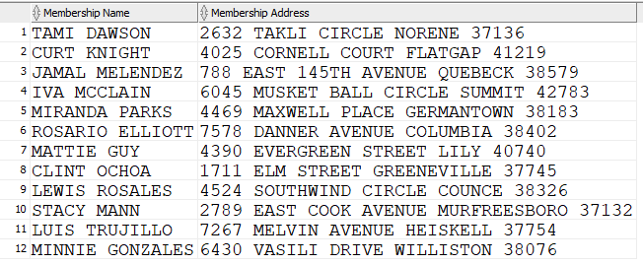

**26.Write a query to display the rental number, rental date, video number, movie title, due date, and return date for all videos that were returned after the due date. Sort the results by rental number and movie title (result shown in Figure P7.94).**

SELECT R.RENT_NUM, R.RENT_DATE, D.VID_NUM, M.MOVIE_TITLE, D.DETAIL_DUEDATE, D.DETAIL_RETURNDATE

From rental r,detailrental d,video v,movie m

where (r.rent_num = d.rent_num) and (d.vid_num = v.vid_num) and (v.movie_num = m.movie_num)

and D.Detail_ReturnDate > D.DETAIL_DUEDATE

order by r.rent_num,m.movie_title;

OR

SELECT R.RENT_NUM, R.RENT_DATE, D.VID_NUM, M.MOVIE_TITLE, D.DETAIL_DUEDATE, D.DETAIL_RETURNDATE

FROM RENTAL R JOIN DETAILRENTAL D

ON R.RENT_NUM = D.RENT_NUM

JOIN VIDEO V

ON D.VID_NUM = V.VID_NUM

JOIN MOVIE M

ON V.MOVIE_NUM = M.MOVIE_NUM

WHERE D.Detail_ReturnDate > D.DETAIL_DUEDATE

Order by R.Rent_Num, M.Movie_Title;

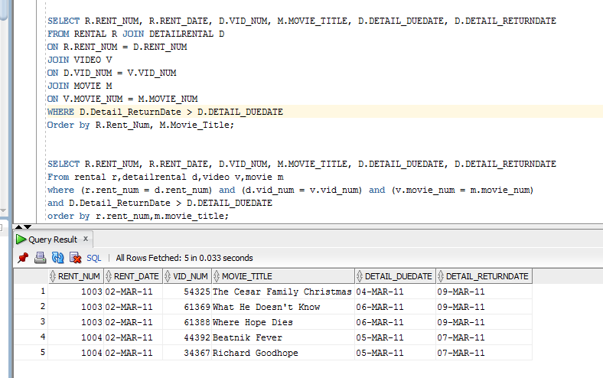

**27.Write a query to display the rental number, rental date, video number, movie title, due date, return date, detail fee, and number of days past the due date that the video was returned for each video that was returned after the due date. Sort the results by rental number and movie title. (Result shown in Figure P7.95.)**

SELECT R.RENT_NUM, R.RENT_DATE, D.VID_NUM, M.MOVIE_TITLE, D.DETAIL_DUEDATE, D.DETAIL_RETURNDATE, D.DETAIL_FEE, (D.DETAIL_RETURNDATE-D.DETAIL_DUEDATE) "Days Past Due"

from rental r,detailrental d,video v, movie m

where (r.rent_num = d.rent_num) and (d.vid_num = v.vid_num) and (v.movie_num = m.movie_num)

and D.Detail_ReturnDate > D.DETAIL_DUEDATE

order by r.rent_num,m.movie_title;

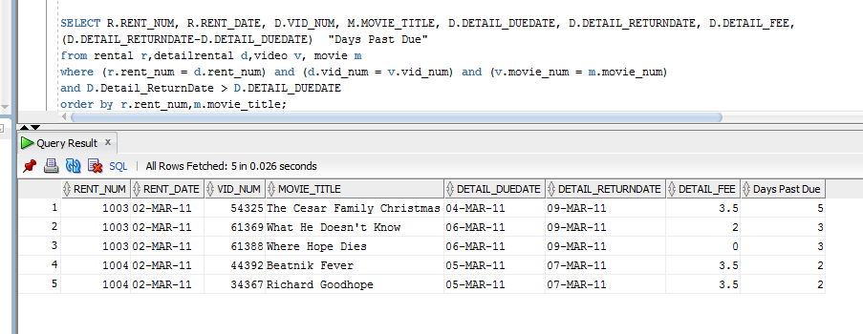

**28.Write a query to display the rental number, rental date, movie title, and detail fee for each movie that was returned on or before the due date (result shown in Figure P7.96).**

Select r.RENT_NUM,r.RENT_DATE,m.MOVIE_TITLE,d.DETAIL_FEE

FROM RENTAL R JOIN DETAILRENTAL D

ON R.RENT_NUM = D.RENT_NUM

JOIN VIDEO V

ON D.VID_NUM = V.VID_NUM

JOIN MOVIE M

ON V.MOVIE_NUM = M.MOVIE_NUM

WHERE D.Detail_ReturnDate <= D.DETAIL_DUEDATE

order by r.rent_num,m.movie_title;

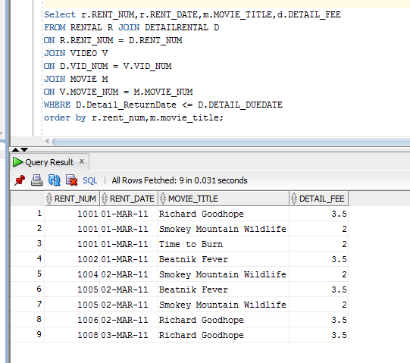

**29.Write a query to display the membership number, last name, and total rental fees earned from that membership (result shown in Figure P7.97). The total rental fee is the sum of all of the detail fees (without the late fees) from all movies that the membership has rented.**

Select m.mem_num, m.mem_lname,sum(d.detail_fee) "Total Rental Fee"

from membership m, rental r, detailrental d

where (m.mem_num = r.mem_num) and (r.rent_num = d.rent_num)

group by m.mem_num,m.mem_lname

order by m.mem_num;

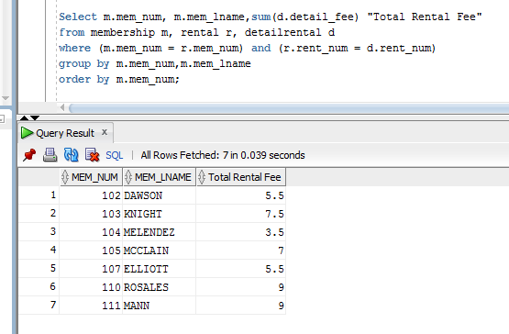

30.**Write a query to display the movie number, movie genre, average movie cost of movies in that genre,**

**movie cost of that individual movie, and the percentage difference between the average movie cost and**

**the individual movie cost (result shown in Figure P7.98).**

SELECT m.MOVIE_NUM, m.MOVIE_GENRE, AVG(e.MOVIE_COST) "AVERAGE MOVIE COST",  
e.MOVIE_COST, ((m.MOVIE_COST - AVG(m.MOVIE_COST))/AVG(e.MOVIE_COST))*100 "PERECENT DIFFERENCE"  
FROM MOVIE m, MOVIE e  
where m.movie_num = e.movie_num  
GROUP BY m.MOVIE_GENRE,m.MOVIE_NUM, m.MOVIE_COST  
order by m.movie_num;

